Application
Kawartha Haliburton Victim Services Board of Directors

Name Phone

Address

Briefly describe your past involvement with other Boards, councils, committees and other related activities (attach a resume if relevant).

List the top three reasons why you would like to join the Kawartha Haliburton Victim Services (KHVS) Board of Directors.

Summarize your experience with and/or interest in our organization.

Area(s) of expertise/Contribution you feel you can make (such as Law, Finance, etc).

What personal strengths would you bring to the KHVS Board of Directors?

Board meetings take up approximately 3 hours per month, are you willing to commit to this time?

Please complete using a scale of High (3) to Low/Not Applicable (1) to reflect your level of experience possessed in a particular area.

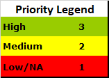
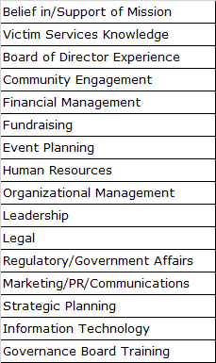

For Board Use
Nominee has been interviewed by the Nominating Committee. Date

Recommend candidate as a Board member Yes / No

Date start with the Board Date

Select one >> 1-year term 2-year term

